Investigation 11A: THUNDERSTORMS

1. "As a general rule of thumb, the greater the altitude of the top of a thunderstorm cloud (cumulonimbus), the more intense the thunderstorm cell. A relatively high thunderstorm top implies vigorous convection and a relatively ________ updraft."
- weak
- strong

2. "Within a thunderstorm cell, the temperature ________ with increasing altitude primarily because of the expansion of rising air within the cloud."
- falls
- rises

3. "An intense thunderstorm thus has a relatively ________ cloud top."
- cold
- warm

4. "On a visible satellite image, a large thunderstorm can appear as a bright white blotch, or cluster. The brightness of the blotch indicates that the cloud top has a relatively ________ albedo for visible solar radiation."
- high
- low

Applications

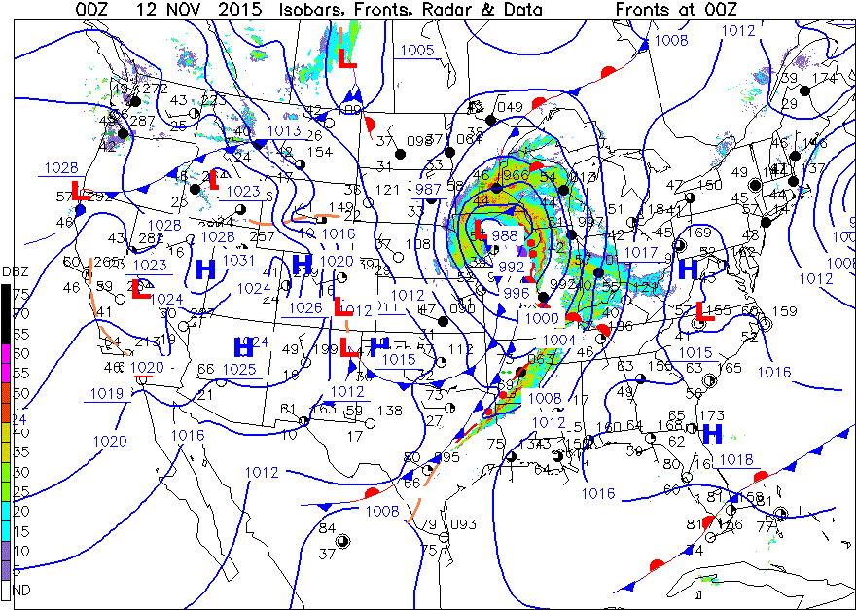

5. "Note the temperature and dewpoint in the station model at Lake Charles, in southwestern LA. Lake Charles’ temperature at map time was ________ °F and the dewpoint was 71 °F. Lake Charles was ahead of the approaching cold front and squall line."
- 78
- 75
- 67

6. "The temperature at Wichita, in south-central Kansas, was 47 °F with a dewpoint of ________ °F. Wichita was behind the trailing cold front and was representative of the cold air mass advancing into the country."
- 26
- 31
- 48

7. "Dewpoints as shown by station models across the Southeastern states indicated air with relatively ________ concentrations of water vapor compared to stations behind the cold front. (A guide is that an increase of 18 F° in dewpoint indicates about a doubling of water vapor concentration.)"
- high
- low

8. "Winds from Brownsville, in southernmost Texas, to the Florida panhandle, displayed a generally ________ flow of humid air ahead of the cold fronts."
- northward
- southward

9. "The wind direction at Little Rock, in central Arkansas, was shown as about 15 knots generally from a ________ direction near the southern squall line."
- southerly
- northerly

10. "Radar reflectivity shadings of red splotches and lines showed that precipitation intensities associated with both the north and southern portions of squall lines were relatively ________."
- weak
- strong

11. "Such relatively small areas of high precipitation values would likely be associated with ________."
- widespread light rainfall
- local strong thunderstorms

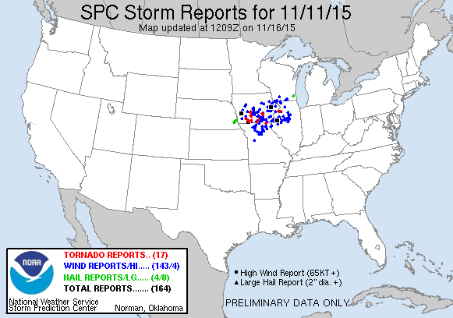

12. "The location of the reports ________ likely related to the passing low-pressure center of the storm system and the northern squall line."
- were
- were not

13. "The combination of these types of weather occurrences are typically only related to thunderstorm activity. Therefore, we can confidently conclude that thunderstorms ________ occurring in areas of red radar echoes near map time."
- were
- were not

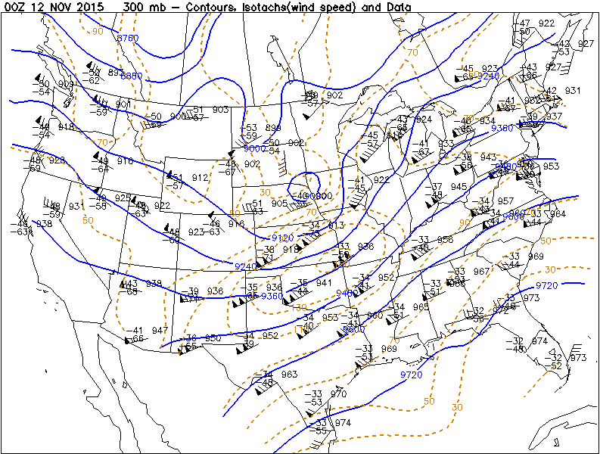

14. "The surface Low center was positioned to the ________ of the closed contour marking the low heights within the trough of the upper air wind pattern in the north-central U.S. area. Such positioning often occurs with strong, rapidly moving cyclonic systems."
- west
- north
- east
- south

15. "The Springfield, Missouri, upper air station model shows a wind speed of ________ knots within a small, brown oval isotach near that station."
- 60
- 75
- 100
- 150

16. "Shade the area within this isotach. This relatively higher wind speed region is evidence that a ________ existed aloft within jet stream winds."
- jet streak
- calm area

17. "The upper air winds displayed the trough’s axis positioned slightly to the west of the surface storm center. Also strong jet winds with a jet streak pattern were over the central U.S. at 00Z on 12 November 2015. This flow pattern indicated divergence at this upper tropospheric level, a lifting mechanism for surface and lower tropospheric air. These upper level wind features suggest that support in the upper troposphere needed for thunderstorm formation and development ________ exist across this region."
- did
- did not

18. "The Figure 1 surface map ________ show favorable low-level moisture and a trigger mechanism while Figure 3 shows evidence of supportive upper atmospheric conditions, all of which contributed to thunderstorm development."
- does
- does not

